PATHSHALA NEPAL FOUNDATION

PRE-UNI PROGRAM

Baneshwor, Kathmandu



Lab assessment report on

Problems Based on Using Array

**Submitted By:** **Submitted To**

Name: Raunak Raj Adhikari Department of Computer Science

Class: 11 PATHSHALA NEPAL FOUNDATION

Group: 1

Date: 2023-05-09

1. write a C program to read the following numbers and find out the sum and average, -123, 23, 100, 200, 30, 400, 2000, 3452, 34, -1234, 234, 231, 400, 24

#include <stdio.h>

int main()

{

int num[12] = {-123, 23, 100, 200, 30, 400, 2000, 3452, 34, -1234, 234, 231};

int sum = 0;

float avg;

for (int i = 0; i < 12; i++)

{

sum += num[i];

}

avg = (float)sum / 12;

printf("Sum of the numbers: %d\n", sum);

printf("Average of the numbers: %.2f\n", avg);

return 0;

}

Output:

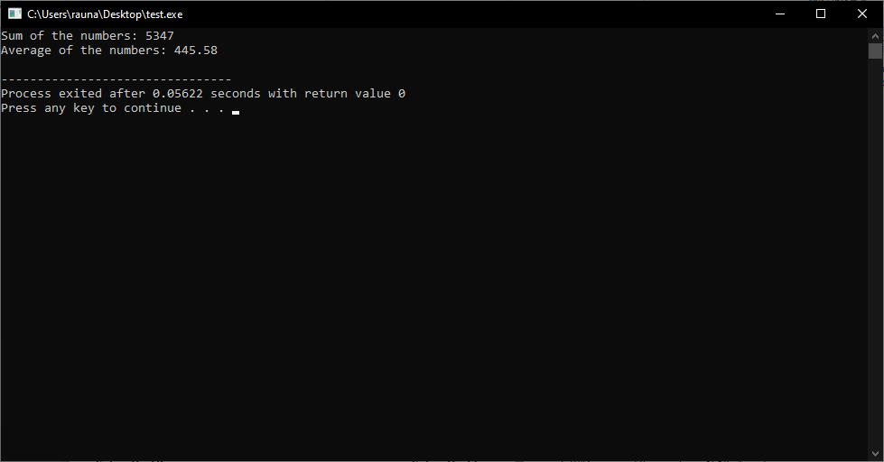

2. write a c program to read the follow numbers and find out maximum value, -123, 23, 100, 200, 30, 400, 2000, 3452, 34, -1234, 234, 231, 400, 24

#include <stdio.h>

int main()

{

int nums[] = {-123, 23, 100, 200, 30, 400, 2000, 3452, 34, -1234, 234, 231, 400, 24};

int max = nums[0];

int i;

for (i = 1; i < 14; i++)

{

if (nums[i] > max)

{

max = nums[i];

}

}

printf("The maximum value is %d", max);

return 0;

}

Output:

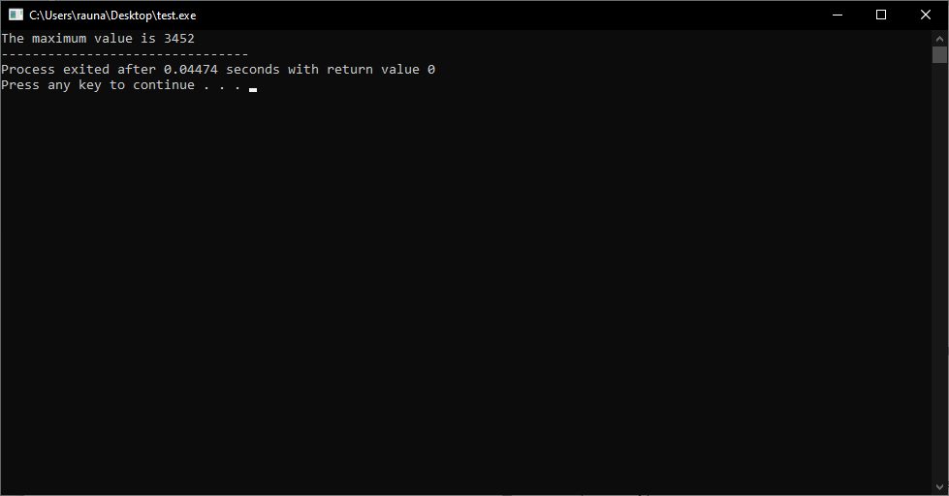

3. write a c program to read the following numbers and find out minimum, -123, 23, 100, 200, 30, 400, 2000, 3452, 34, -1234, 234, 231, 400, 24

#include <stdio.h>

int main()

{

int nums[] = {-123, 23, 100, 200, 30, 400, 2000, 3452, 34, -1234, 234, 231, 400, 24};

int min = nums[0];

int i;

for (i = 1; i < 14; i++)

{

if (nums[i] < min)

{

min = nums[i];

}

}

printf("Minimum number is: %d", min);

return 0;

}

Output:

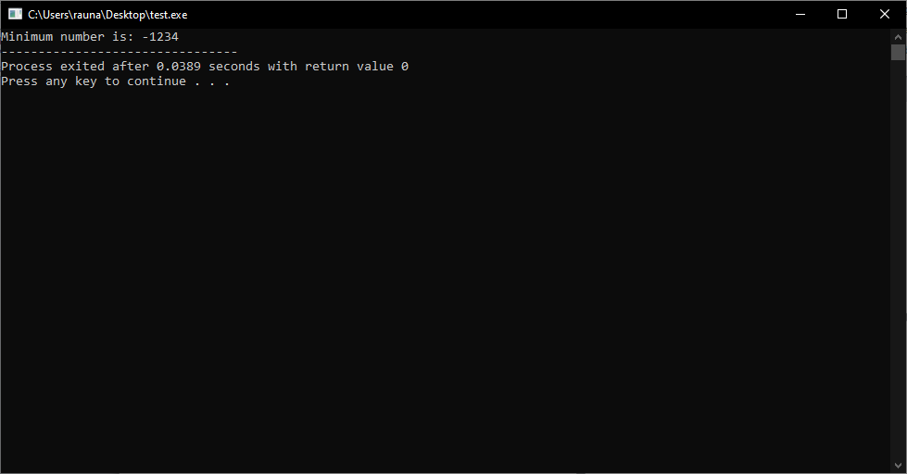

4. write a c program to read 15 different numbers supplied by a user and find the sum and average of them

#include <stdio.h>

int main()

{

int i, num, sum = 0;

float avg;

printf("Enter 15 different numbers: \n");

for(i=1; i<=15; i++)

{

scanf("%d", &num);

sum += num;

}

avg = (float)sum/15;

printf("Sum of 15 numbers = %d\n", sum);

printf("Average of 15 numbers = %.2f\n", avg);

return 0;

}

Output:

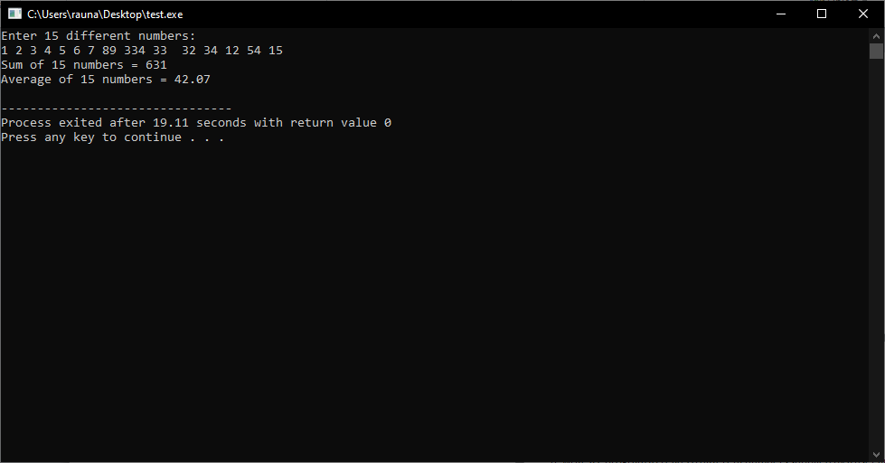

5. write a c program to read 12 different numbers supplied by a user and find the maximum value among them

#include <stdio.h>

int main()

{

int num[12], max;

printf("Enter 12 numbers: \n");

for (int i = 0; i < 12; i++)

{

scanf("%d", &num[i]);

}

max = num[0];

for (int i = 1; i < 12; i++)

{

if (num[i] > max)

{

max = num[i];

}

}

printf("The maximum value is %d\n", max);

return 0;

}

Output:

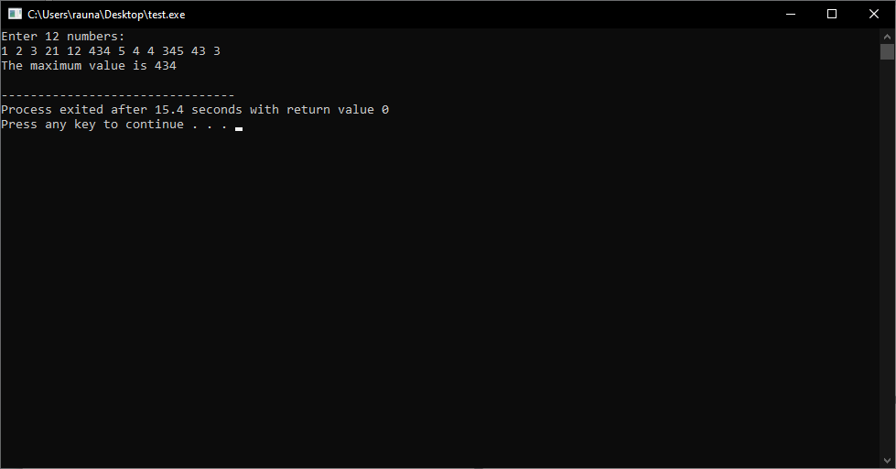

6. write a c program to read 20 different numbers supplied by a user and find minimum value among them

#include <stdio.h>

int main()

{

int i, num, min;

printf("Enter 20 different numbers: \n");

scanf("%d", &num);

min = num;

for(i=1; i<20; i++)

{

scanf("%d", &num);

if(num < min)

{

min = num;

}

}

printf("Minimum value among the numbers is: %d", min);

return 0;

}

Output:

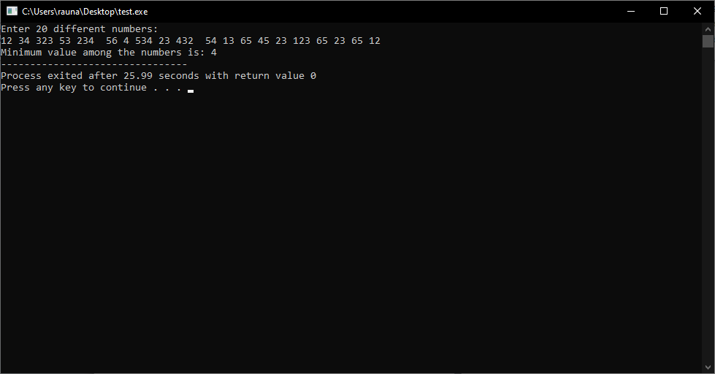

7. write a c program to read n different numbers supplied by a user and find the summ and average of them

#include <stdio.h>

int main()

{

int n, i;

float num[100], sum = 0.0, average;

printf("Enter the numbers of elements: ");

scanf("%d", &n);

while (n > 100 || n <= 0)

{

printf("Error! number should in range of (1 to 100).\n");

printf("Enter the number again: ");

scanf("%d", &n);

}

for(i = 0; i < n; ++i)

{

printf("%d. Enter number: ", i+1);

scanf("%f", &num[i]);

sum += num[i];

}

average = sum / n;

printf("Average = %.2f", average);

return 0;

}

Output:

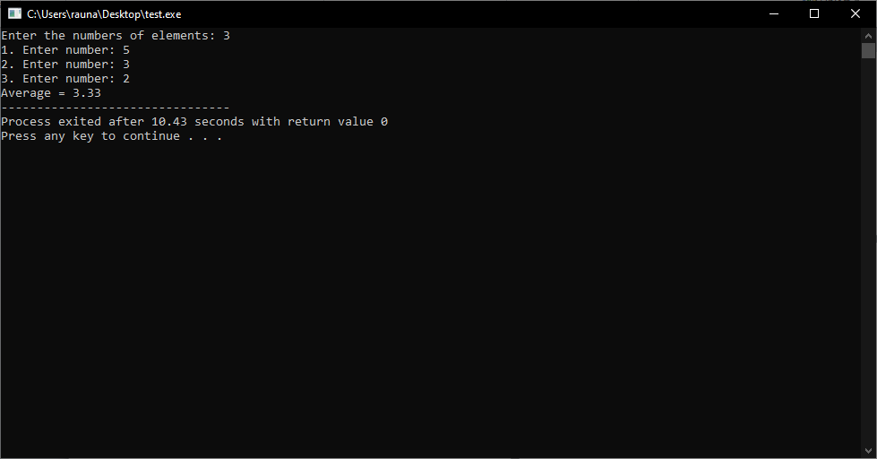

8. write a c program to read n different numbers supplied by a user and find the maxumum value among them

#include <stdio.h>

int main()

{

int n, i;

int max = 0;

printf("Enter the number of elements: ");

scanf("%d", &n);

int arr[n];

printf("Enter %d elements: \n", n);

for(i = 0; i < n; i++)

{

scanf("%d", &arr[i]);

if(arr[i] > max)

{

max = arr[i];

}

}

printf("Maximum element is %d", max);

return 0;

}

Output:

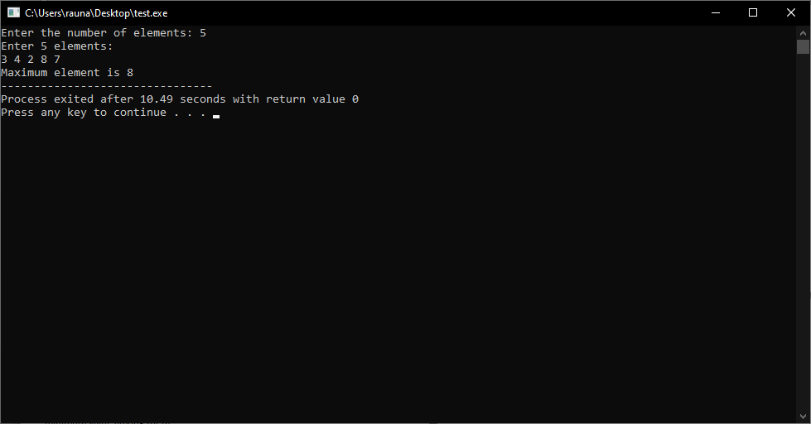

9. write a c program to read n different number supplied by a user and find the minimum value among them

#include <stdio.h>

int main()

{

int n, i;

int min;

printf("Enter the number of elements: ");

scanf("%d", &n);

int arr[n];

printf("Enter the elements: \n");

for(i=0; i<n; i++)

{

scanf("%d", &arr[i]);

}

min = arr[0];

for(i=1; i<n; i++)

{

if(arr[i] < min)

{

min = arr[i];

}

}

printf("Minimum element is %d", min);

return 0;

}

Output:

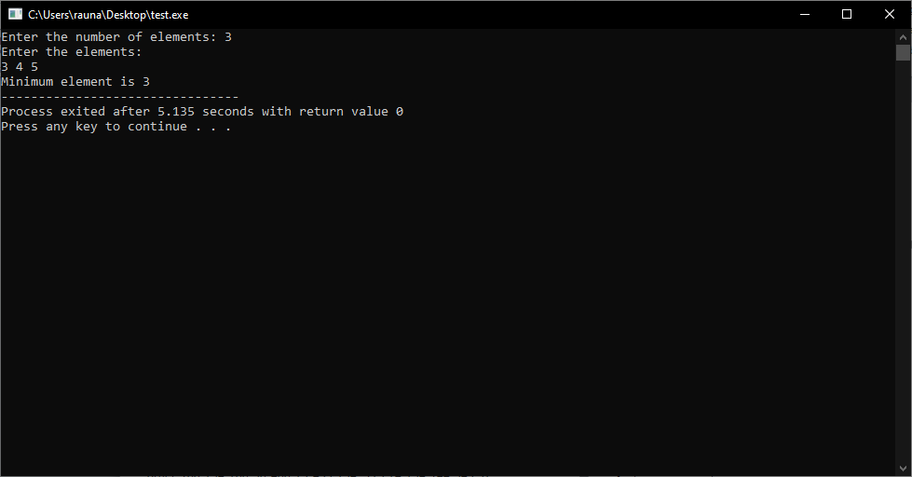

10. write a c program, which reads following numbers and sort them in ascending order. 100, 234, 200, 30, 400, 23, 433, 234, -123, 24, 234, 144, 543, 32

#include <stdio.h>

int main()

{

int numbers[13] = {100, 234, 200, 30, 400, 23, 433, 234, -123, 24, 234, 144, 543};

int i, j, temp;

// sorting the numbers in ascending order

for (i = 0; i < 13; i++)

{

for (j = i + 1; j < 13; j++)

{

if (numbers[i] > numbers[j])

{

temp = numbers[i];

numbers[i] = numbers[j];

numbers[j] = temp;

}

}

}

// printing the sorted numbers

printf("Sorted numbers in ascending order: \n");

for (i = 0; i < 13; i++)

{

printf("%d\n", numbers[i]);

}

return 0;

}

Output:

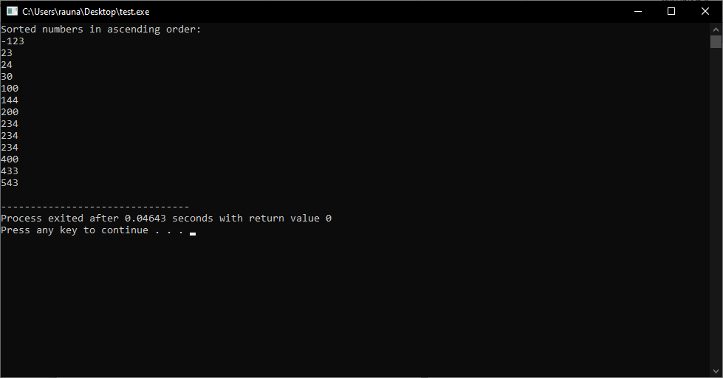

11. write a c program, which reads following numbers and sort them in descending order. 100, 234, 200, 30, 400, 23, 433, 234, -123, 24, 234, 144, 543, 32

#include <stdio.h>

int main()

{

int numbers[13] = {100, 234, 200, 30, 400, 23, 433, 234, -123, 24, 234, 144, 543};

int i, j, temp;

// sorting the array in descending order

for (i = 0; i < 13; i++)

{

for (j = i + 1; j < 13; j++)

{

if (numbers[i] < numbers[j])

{

temp = numbers[i];

numbers[i] = numbers[j];

numbers[j] = temp;

}

}

}

// printing the sorted array

printf("Sorted array in descending order: \n");

for (i = 0; i < 13; i++)

{

printf("%d\n", numbers[i]);

}

return 0;

}

Output:

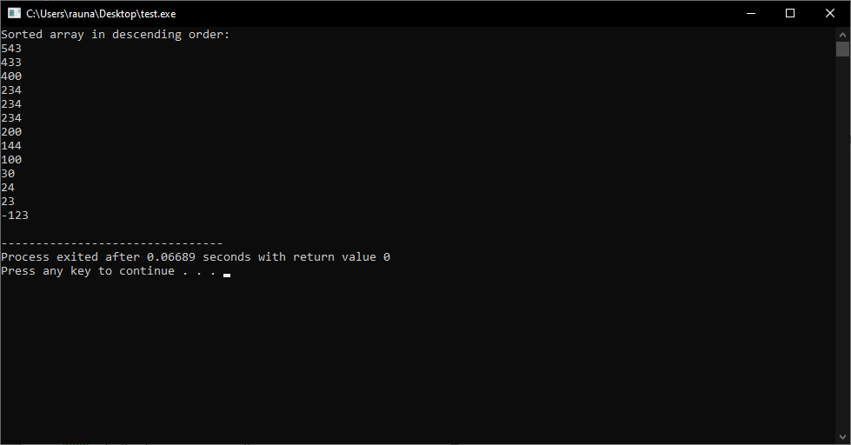

12. write a c program, which reads following numbers and find the median value. 100, 234, 200, 30, 400, 23, 433, 234, -123, 24, 234, 144, 543, 32

#include <stdio.h>

#include <stdlib.h>

int main()

{

int arr[13] = {100, 234, 200, 30, 400, 23, 433, 234, -123, 24, 234, 144, 543};

int i, j, temp;

int median;

// sorting the array

for (i = 0; i < 13; i++)

{

for (j = i + 1; j < 13; j++)

{

if (arr[i] > arr[j])

{

temp = arr[i];

arr[i] = arr[j];

arr[j] = temp;

}

}

}

// calculating the median

if (13 % 2 == 0)

{

median = (arr[6] + arr[7]) / 2;

}

else

{

median = arr[6];

}

printf("The median value is %d", median);

return 0;

}

Output:

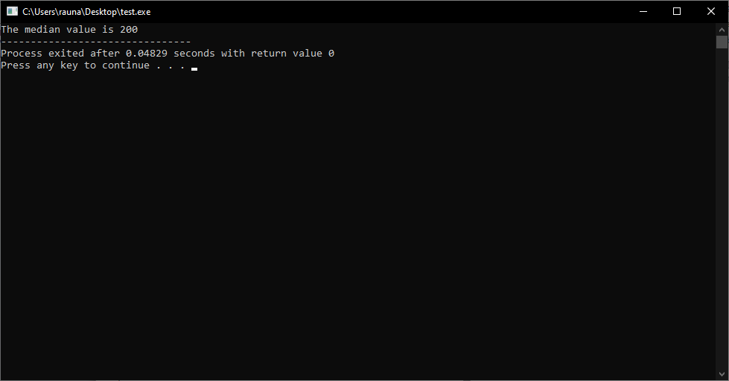

13. write a c program, which accepts any 20 different numbers and find out the sum, average, the largest and the smallest value among them.

#include<stdio.h>

int main()

{

int i, n, sum = 0, largest, smallest;

float avg;

int arr[20];

printf("Enter the number of elements in the array: ");

scanf("%d", &n);

printf("Enter the elements of the array: \n");

for(i=0; i<n; i++)

{

scanf("%d", &arr[i]);

}

// Calculating the sum of the elements

for(i=0; i<n; i++)

{

sum = sum + arr[i];

}

// Calculating the average of the elements

avg = (float)sum/n;

// Finding the largest element

largest = arr[0];

for(i=1; i<n; i++)

{

if(largest < arr[i])

largest = arr[i];

}

// Finding the smallest element

smallest = arr[0];

for(i=1; i<n; i++)

{

if(smallest > arr[i])

smallest = arr[i];

}

printf("Sum of the elements: %d\n", sum);

printf("Average of the elements: %.2f\n", avg);

printf("Largest element: %d\n", largest);

printf("Smallest element: %d\n", smallest);

return 0;

}

Output:

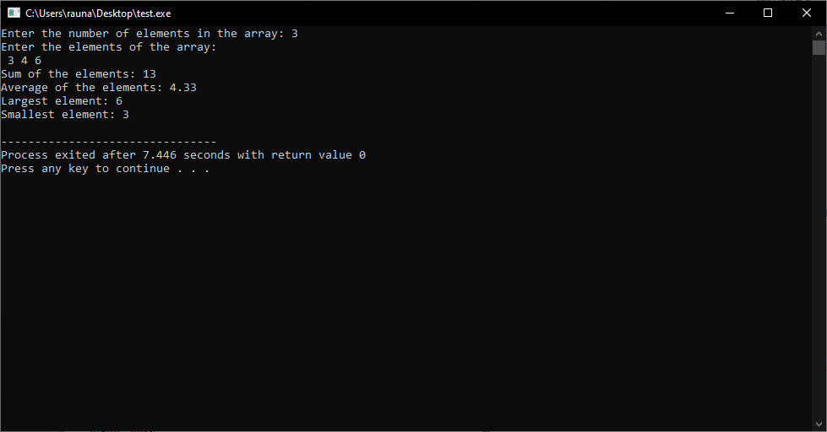

14. write a c program, which accepts n different number and arrange them in ascending order.

#include <stdio.h>

int main()

{

int n, i, j, temp;

printf("Enter the number of elements: ");

scanf("%d", &n);

int arr[n];

printf("Enter %d elements: \n", n);

for(i=0; i<n; i++)

{

scanf("%d", &arr[i]);

}

for(i=0; i<n; i++)

{

for(j=i+1; j<n; j++)

{

if(arr[i] > arr[j])

{

temp = arr[i];

arr[i] = arr[j];

arr[j] = temp;

}

}

}

printf("The elements in ascending order are: \n");

for(i=0; i<n; i++)

{

printf("%d\n", arr[i]);

}

return 0;

}

Output:

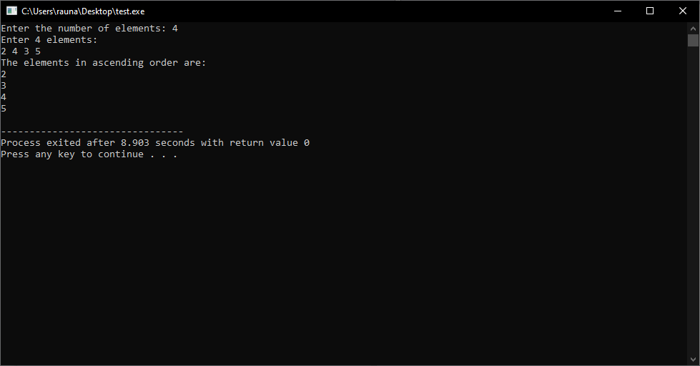

15. write a c program, which accepts n different number and arrange them in descending order

#include<stdio.h>

int main()

{

int n, i, j, temp;

printf("Enter the number of elements: ");

scanf("%d", &n);

int arr[n];

printf("Enter the elements: \n");

for(i=0; i<n; i++)

{

scanf("%d", &arr[i]);

}

for(i=0; i<n; i++)

{

for(j=i+1; j<n; j++)

{

if(arr[i] < arr[j])

{

temp = arr[i];

arr[i] = arr[j];

arr[j] = temp;

}

}

}

printf("The elements in descending order are: \n");

for(i=0; i<n; i++)

{

printf("%d\n", arr[i]);

}

return 0;

}

Output:

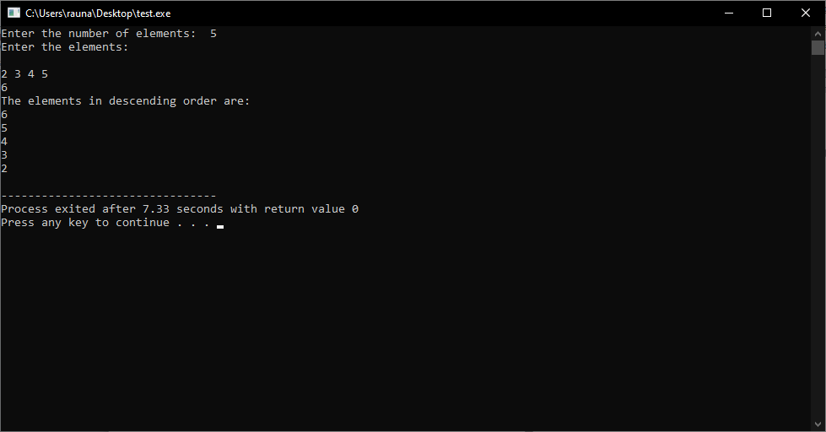

16. write a c program, which asks you to input any 15 different numbers and sort them in ascending order.

#include <stdio.h>

int main()

{

int i, j, temp, arr[15];

printf("Please enter 15 different numbers: \n");

// Input 15 numbers

for (i = 0; i < 15; i++)

{

scanf("%d", &arr[i]);

}

// Sort the numbers in ascending order

for (i = 0; i < 15; i++)

{

for (j = i + 1; j < 15; j++)

{

if (arr[i] > arr[j])

{

temp = arr[i];

arr[i] = arr[j];

arr[j] = temp;

}

}

}

// Print the sorted numbers

printf("The numbers in ascending order are: \n");

for (i = 0; i < 15; i++)

{

printf("%d ", arr[i]);

}

return 0;

}

Output:

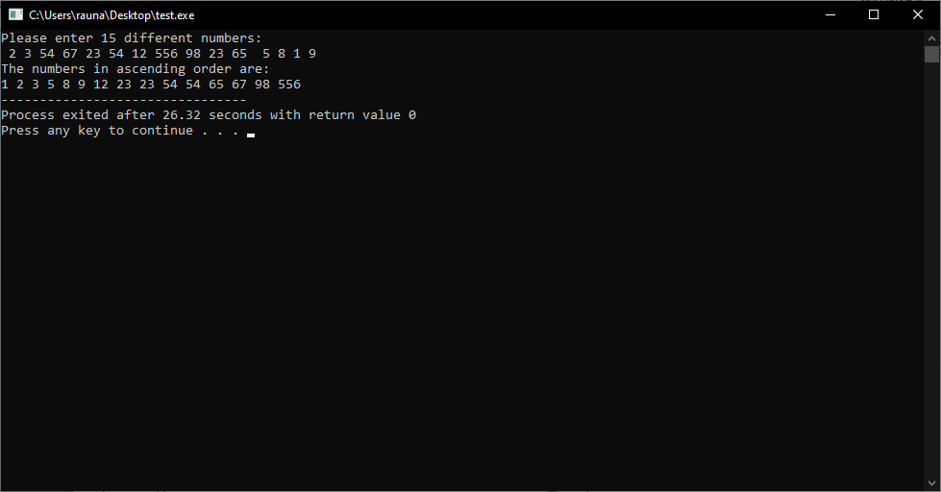

17. write a c program, which asks you to input any 25 different numbers and sort them in descending order.

#include <stdio.h>

int main()

{

int i, j, temp, arr[25];

printf("Enter 25 different numbers: \n");

// Input 25 numbers

for (i = 0; i < 25; i++)

{

scanf("%d", &arr[i]);

}

// Sort the numbers in descending order

for (i = 0; i < 24; i++)

{

for (j = i + 1; j < 25; j++)

{

if (arr[i] < arr[j])

{

temp = arr[i];

arr[i] = arr[j];

arr[j] = temp;

}

}

}

// Print the sorted numbers

printf("Sorted numbers in descending order: \n");

for (i = 0; i < 25; i++)

{

printf("%d\n", arr[i]);

}

return 0;

}

Output:

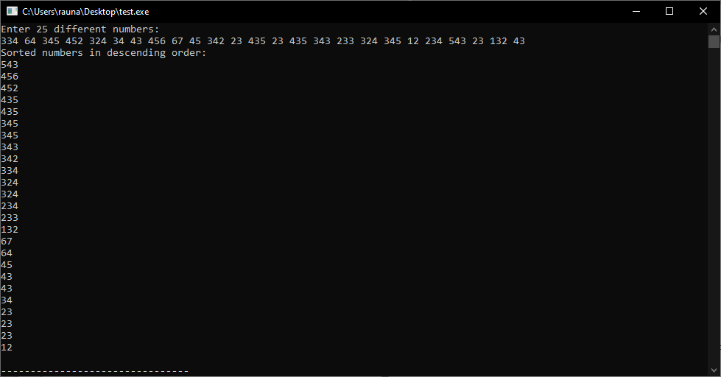

18. write a c program, which asks you to input any 25 different numbers and find the median value

#include <stdio.h>

int main()

{

int num[25], i, j, temp;

float median;

printf("Enter 25 different numbers: \n");

// Store numbers entered by the user

for (i = 0; i < 25; ++i)

{

scanf("%d", &num[i]);

}

// Sort the numbers in ascending order

for (i = 0; i < 25; ++i)

{

for (j = i + 1; j < 25; ++j)

{

if (num[i] > num[j])

{

temp = num[i];

num[i] = num[j];

num[j] = temp;

}

}

}

// Calculate the median

if (25 % 2 == 0)

{

median = (num[12] + num[13]) / 2.0;

}

else

{

median = num[12];

}

printf("Median = %.2f", median);

return 0;

}

Output:

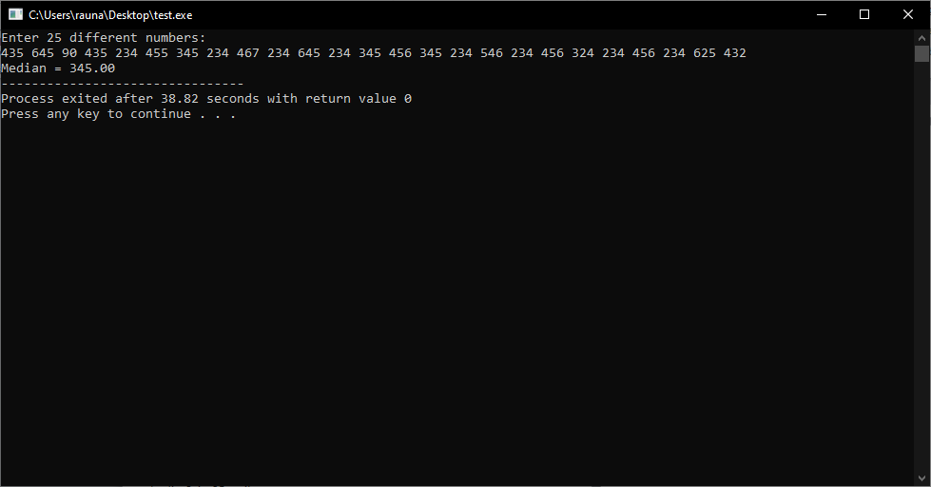

19. write a c program, which accepts any 20 different numbers and find out the total numbers of odd and even valued existed among them

#include<stdio.h>

int main()

{

int num[20], i, even = 0, odd = 0;

printf("Enter 20 different numbers: \n");

for(i=0; i<20; i++)

{

scanf("%d", &num[i]);

if(num[i]%2 == 0)

even++;

else

odd++;

}

printf("Total even numbers: %d\n", even);

printf("Total odd numbers: %d\n", odd);

return 0;

}

Output:

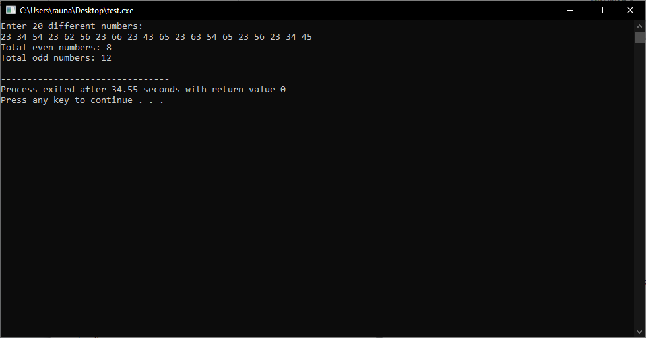

20. write a c program, which accepts n different numbers and find the total number of values which are divisible by 3 or 5.

#include<stdio.h>

int main()

{

int n,i,count=0;

printf("Enter the number of elements: ");

scanf("%d",&n);

int arr[n];

printf("Enter the elements: \n");

for(i=0;i<n;i++)

{

scanf("%d",&arr[i]);

if(arr[i]%3==0 || arr[i]%5==0)

count++;

}

printf("The total number of values which are divisible by 3 or 5 is %d",count);

return 0;

}

Output:

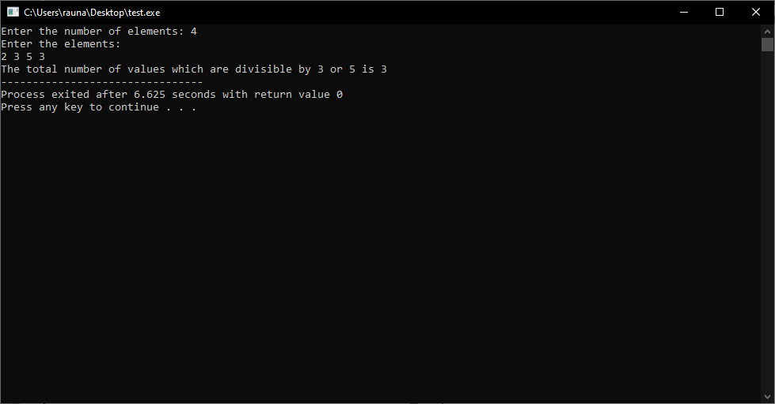

21. write a c program, which accepts n different numbers and count and display all the prime numbers among them

#include<stdio.h>

int main()

{

int n,i,j,count=0;

printf("Enter the number of elements: ");

scanf("%d",&n);

int a[n];

printf("Enter the elements: ");

for(i=0;i<n;i++)

{

scanf("%d",&a[i]);

}

printf("The prime numbers are: ");

for(i=0;i<n;i++)

{

count=0;

for(j=1;j<=a[i];j++)

{

if(a[i]%j==0)

{

count++;

}

}

if(count==2)

{

printf("%d ",a[i]);

}

}

return 0;

}

Output:

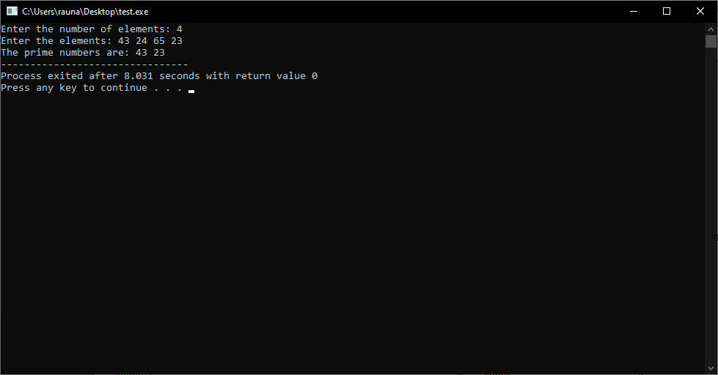

22. write a c program to accept n different numbers and find out the frequency of each value in the given number range.

#include<stdio.h>

int main()

{

int n, i, j, count;

printf("Enter the number of elements: ");

scanf("%d", &n);

int arr[n];

printf("Enter the elements: ");

for(i=0; i<n; i++)

{

scanf("%d", &arr[i]);

}

printf("\nFrequency of each value in the given number range: \n");

for(i=0; i<n; i++)

{

count = 1;

for(j=i+1; j<n; j++)

{

if(arr[i]==arr[j])

{

count++;

arr[j] = -1;

}

}

if(arr[i]!=-1)

{

printf("%d occurs %d times\n", arr[i], count);

}

}

return 0;

}

Output:

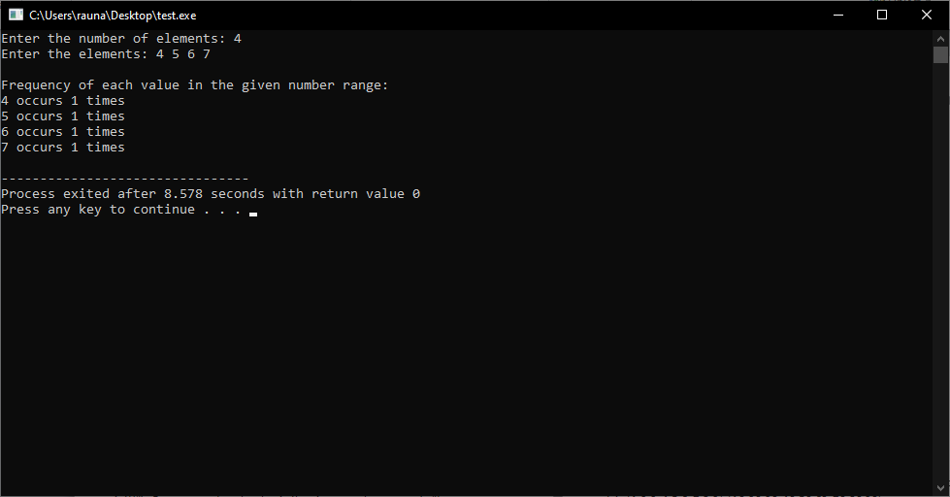

23. Write a C program to read the following two 3 x 3 matrices and find the sum matrix [1,2,3 4,5,6 7,8,9] [10,20,30 40,50,60 70,80,90]

#include <stdio.h>

int main()

{

int a[3][3], b[3][3], c[3][3], i, j;

printf("Enter elements of first matrix\n");

for (i = 0; i < 3; i++)

{

for (j = 0; j < 3; j++)

{

scanf("%d", &a[i][j]);

}

}

printf("Enter elements of second matrix\n");

for (i = 0; i < 3; i++)

{

for (j = 0; j < 3; j++)

{

scanf("%d", &b[i][j]);

}

}

printf("Sum of the matrices:\n");

for (i = 0; i < 3; i++)

{

for (j = 0; j < 3; j++)

{

c[i][j] = a[i][j] + b[i][j];

printf("%d\t", c[i][j]);

}

printf("\n");

}

return 0;

}

Output:

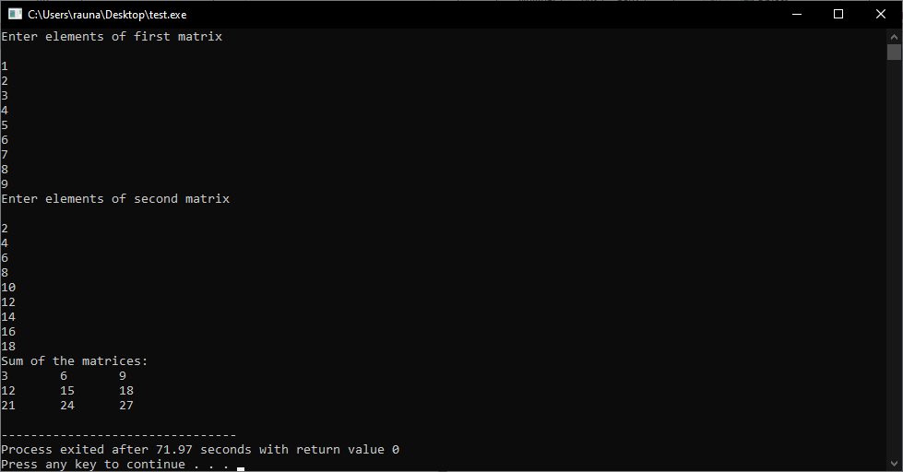

24. write a C program to read the table of following numbers and calculate the horizontal and vertical total Row-1:[34,54,67,100,?], Row-2:[-45,20,123,122,?], Row-3:[200,34,44,25,?], Row-4:[?,?,?,?,?]

#include<stdio.h>

int main()

{

int row1[5] = {34,54,67,100,0};

int row2[5] = {-45,20,123,122,0};

int row3[5] = {200,34,44,25,0};

int row4[5] = {0,0,0,0,0};

int i, sum1=0, sum2=0, sum3=0, sum4=0;

//Calculating the horizontal total

for(i=0; i<5; i++)

{

sum1 += row1[i];

sum2 += row2[i];

sum3 += row3[i];

sum4 += row4[i];

}

row1[4] = sum1;

row2[4] = sum2;

row3[4] = sum3;

row4[4] = sum4;

//Calculating the vertical total

for(i=0; i<5; i++)

{ row4[i] = row1[i] + row2[i] + row3[i] + row4[i]; }

//Printing the table

printf("Row-1: [%d, %d, %d, %d, %d]\n", row1[0], row1[1], row1[2], row1[3], row1[4]);

printf("Row-2: [%d, %d, %d, %d, %d]\n", row2[0], row2[1], row2[2], row2[3], row2[4]);

printf("Row-3: [%d, %d, %d, %d, %d]\n", row3[0], row3[1], row3[2], row3[3], row3[4]);

printf("Row-4: [%d, %d, %d, %d, %d]\n", row4[0], row4[1], row4[2], row4[3], row4[4]);

return 0;

}

Output:

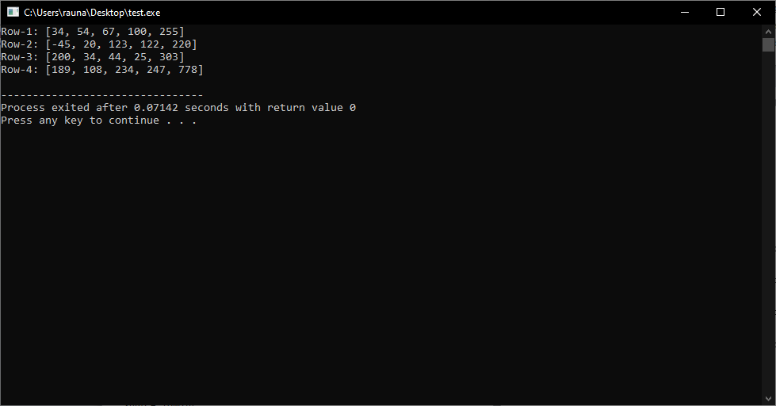

25. Write a c program, which reads the following sales chart and calculate the day wise and item wise total. Day:[SUN, MON, TUE, WED, THU, FRI], LUX:[1000,400,300,350,600,1000], SOALTEE:[2000,1200,200,150,500,2300], RIN:[1300,200,500,600,700,500], TOTAL:[?,?,?,?,?,?], ROW-8:TOTAL[?,?,?,?]

#include<stdio.h>

int main()

{

int lux[6] = {1000,400,300,350,600,1000},

soaltee[6] = {2000,1200,200,150,500,2300},

rin[6] = {1300,200,500,600,700,500},

total[6] = {0,0,0,0,0,0},

row8[4] = {0,0,0,0},

i;

for(i=0;i<6;i++)

{

total[i]=lux[i]+soaltee[i]+rin[i];

}

row8[0] = lux[0] + lux[1] + lux[2] + lux[3] + lux[4] + lux[5];

row8[1] = lux[0] + lux[1] + lux[2] + lux[3] + lux[4] + lux[5];

row8[2] = soaltee[0] + soaltee[1] + soaltee[2] + soaltee[3] + soaltee[4] + soaltee[5];

row8[3] = total[0] + total[1] + total[2] + total[3] + total[4] + total[5];

row8[0]=total[0]+total[1]+total[2];

row8[1]=total[3]+total[4]+total[5];

row8[2]=total[0]+total[3];

row8[3]=total[1]+total[4];

printf("Day\tLUX\tSOALTEE\tRIN\tTOTAL\n");

for(i=0;i<6;i++)

{

printf("%d\t%d\t%d\t%d\t%d\n",i+1,lux[i],soaltee[i],rin[i],total[i]);

}

printf("Total\t%d\t%d\t%d\t%d\n",row8[0],row8[1],row8[2],row8[3]);

return 0;

}

Output:

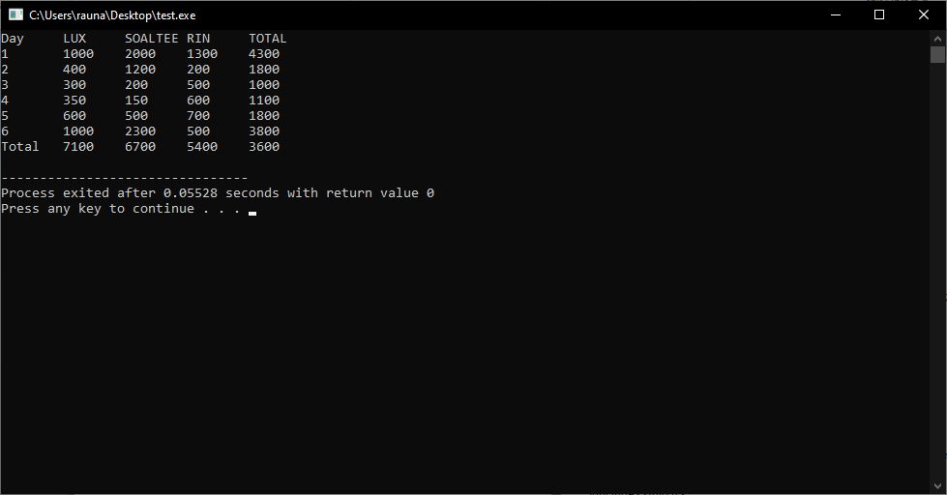

26. Write a C program to ask a user for supplying elements of two different 3x3 matrices and calculate their sum matrix.

#include <stdio.h>

int main()

{

int a[3][3], b[3][3], c[3][3], i, j;

printf("Enter elements of first matrix\n");

for (i = 0; i < 3; i++)

{

for (j = 0; j < 3; j++)

{

scanf("%d", &a[i][j]);

}

}

printf("Enter elements of second matrix\n");

for (i = 0; i < 3; i++)

{

for (j = 0; j < 3; j++)

{

scanf("%d", &b[i][j]);

}

}

printf("Sum of the matrices:\n");

for (i = 0; i < 3; i++)

{

for (j = 0; j < 3; j++)

{

c[i][j] = a[i][j] + b[i][j];

printf("%d\t", c[i][j]);

}

printf("\n");

}

return 0;

}

Output:

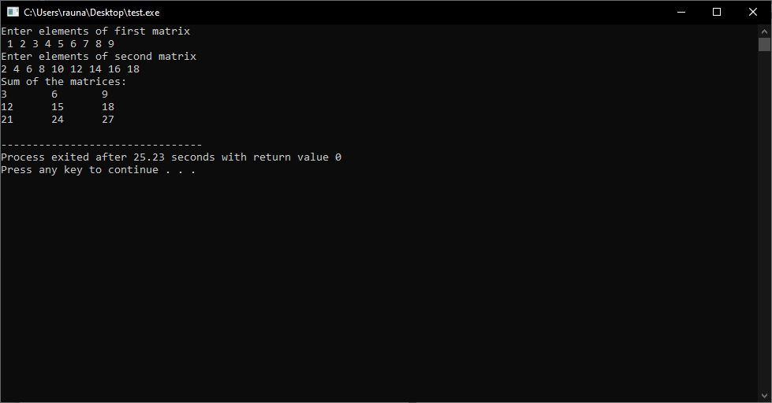

27. Write a c program that reads two matrices A[]M x N and B[]M x N and add them as C(i,j) = A(i,j) + B(i,j).

#include <stdio.h>

int main()

{

int m, n, i, j;

printf("Enter the size of the matrices (m x n): ");

scanf("%d %d", &m, &n);

int A[m][n], B[m][n], C[m][n];

printf("Enter the elements of matrix A:\n");

for (i = 0; i < m; i++)

{

for (j = 0; j < n; j++)

{

scanf("%d", &A[i][j]);

}

}

printf("Enter the elements of matrix B:\n");

for (i = 0; i < m; i++)

{

for (j = 0; j < n; j++)

{

scanf("%d", &B[i][j]);

}

}

// Adding the matrices

for (i = 0; i < m; i++)

{

for (j = 0; j < n; j++)

{

C[i][j] = A[i][j] + B[i][j];

}

}

printf("The sum of the matrices is:\n");

for (i = 0; i < m; i++)

{

for (j = 0; j < n; j++)

{

printf("%d ", C[i][j]);

}

printf("\n");

}

return 0;

}

Output:

